Psalm 118 vv 1-2, 19-29 Common Worship *Chant: Thomas Turton*

Chant on a single line of music:



and on two lines for use in narrow columns:

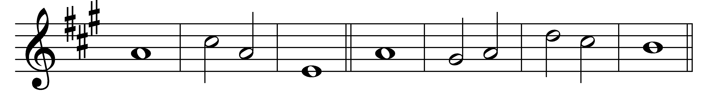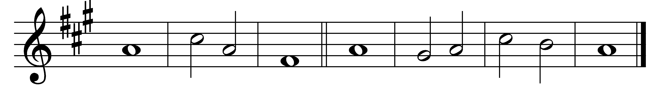

1 O give thanks to the Lord, for | he is | good;

his | mercy· en-| dures for | ever.

2 Let Israel | now pro-| claim,

‘His | mercy· en-| dures for | ever.’

19 Open to me the | gates of | righteousness,

that I may enter | and give | thanks· to the | Lord.

20 This is the | gate· of the | Lord;

the | righteous· shall | enter | through it.

*(2nd part)* 21 I will give thanks to you, for | you have | answered me

and | have be-| come· my sal-| vation.

22 The stone which the | builders· re-| jected→

has be-| come the | chief· corner-| stone.

23 This is the | Lord’s | doing,

and it is | marvel-· lous | in our | eyes.

24 This is the day that the | Lord has | made;

we will re-| joice· and be | glad in | it.

25 Come, O Lord, and | save us· we | pray.

Come, Lord, | send us | now pro-| sperity.

26 Blessed is he who comes in the | name· of the | Lord;

we bless you | from the | house· of the | Lord.

27 The Lord is God; he has | given· us | light;

link the pilgrims with cords | right· to the | horns· of the | altar.

28 You are my God and | I will | thank you;

you are my | God and | I will· ex-| alt you.

29 O give thanks to the Lord, for | he is | good;

his | mercy· en-| dures for | ever.

Words taken from Common Worship © The Archbishops’ Council 2000.